这是我们上午开会涉及到的一些学习资源链接。ES6 和 React 基础是我们每个人都需要先掌握的，其他的部分则是每个人各分担一部分作为重点，学习后将分享给其他队员一起学习。

在学习方面，大家可以以“重点知识”里面涉及到的知识作为重点。ES 6 可以以“学习 ES 2015”作为学习资料，大概了解之后，就可以直接学习 React 基础。而《ECMAScript 6 入门》这本书可以作为补充学习资料。

除了 ES6 和 React 基础，每个人各自负责的部分，可以在这两天了解一下，然后制定学习计划。下周我们的重点是学习 ES6 和 React 基础。周一我们将安装好环境，以及在上午十点开会讨论，然后确定总目标、制定学习时间表等。同时，大概会在周四、五请一些队员分享一些学习 ES6 和 React 基础的经验心得。

在学习过程中，如果有问题，可以发到群里，然后大家互相帮忙解决。有其他好的学习资源也可以分享到群里。

**初步了解**（大家可以阅读这篇文章，对未来一两个月我们将要学习的 React 技术栈有一个初步的了解）

* 初识 Dva：<https://github.com/pigcan/blog/issues/2>

**重点知识**

* <https://github.com/dvajs/dva-knowledgemap>

**ES6**

* 学习 ES2015：<https://segmentfault.com/a/1190000003818502>
* 《ECMAScript 6 入门》：<http://es6.ruanyifeng.com/>

**React 基础**

* 从零开始学 ReactJS（1-4 节）：<https://github.com/carlleton/reactjs101/tree/zh-CN>
* React 入门实例教程：<http://www.ruanyifeng.com/blog/2015/03/react.html>
* Airbnb React/JSX 编码规范：<https://github.com/JasonBoy/javascript/tree/master/react>

**React Native（王秦、Taony）**

* React Native 中文文档：<http://reactnative.cn/docs/0.41/getting-started.html>
* 零基础手把手教React Native实战开发视频：

<http://pan.baidu.com/share/link?shareid=1696146049&uk=3476502651&from=groupmessage&errno=0&errmsg=Auth%20Login%20Sucess&&bduss=&ssnerror=0#list/path=%2F>

**React-Route（吴鹏）**

* React Router 使用教程：<http://www.ruanyifeng.com/blog/2016/05/react_router.html>
* React Router 入门实战教学：

<https://github.com/carlleton/reactjs101/blob/zh-CN/Ch05/react-router-introduction.md>

* React Router 中文文档：<https://react-guide.github.io/react-router-cn/index.html>

**Webpack（超哥）**

* React 开发环境设置与 Webpack 入门教学：

<https://github.com/carlleton/reactjs101/blob/zh-CN/Ch02/webpack-dev-enviroment.md>

* Webpack 中文指南：<http://zhaoda.net/webpack-handbook/index.html>

**Redux（嘉俊、春生）**

* Redux 入门教程：<http://www.ruanyifeng.com/blog/2016/09/redux_tutorial_part_one_basic_usages.html>

<http://www.ruanyifeng.com/blog/2016/09/redux_tutorial_part_two_async_operations.html>

<http://www.ruanyifeng.com/blog/2016/09/redux_tutorial_part_three_react-redux.html>

* Redux 基础概念、实战入门：<https://github.com/carlleton/reactjs101/tree/zh-CN/Ch07>
* Redux 中文文档：<http://cn.redux.js.org/>

**Dva**（基于 redux、redux-saga 和 react-router@2.x 的轻量级前端框架）

* Dva 文档：<https://github.com/dvajs/dva/blob/master/README_zh-CN.md>

**UI 组件**

* Ant Design Mobile（移动端）：<http://mobile.ant.design/>
* Ant Design（桌面端）：<https://ant.design/index-cn>

**HTML、CSS、JavaScript 基础**

* 360 奇舞前端特训营视频（还在更新）：<https://t.75team.com/video>
* FreeCodeCamp（边练边学）：<https://www.freecodecamp.cn/>
* HTML、CSS 编码规范：<http://codeguide.bootcss.com/>
* Airbnb JavaScript 编码规范：<https://github.com/yuche/javascript>

Get started with Dva.js and Ant Design mobile.

<https://github.com/xlsdg/dva-antd-mobile-starter>

<https://github.com/sorrycc/dva-example-antd-mobile>

React Router按需加载

<http://www.tuicool.com/articles/7FrQziY>

React思维方式

<http://www.tuicool.com/articles/qqu2Yra>

Roadhog配置

<https://github.com/sorrycc/roadhog#%E9%85%8D%E7%BD%AE>

配置theme

<https://github.com/dvajs/dva-example-user-dashboard/commit/d6da33b3a6e18eb7f003752a4b00b5a660747c31>

React-router按需加载

<https://github.com/ReactTraining/react-router/tree/master/examples/huge-apps>

React-router的深层嵌套

<http://blog.csdn.net/liningaa/article/details/52790683>

新的环境已经放在 exercise/start  
主要解决了图片、图标的问题  
  
数据交互练习的 API  
<https://cnodejs.org/api>

webpack 环境构建资料  
<https://github.com/daihanqiao/react-hybrid>

<http://www.css88.com/doc/webpack2/>

<https://github.com/brunoyang/blog/issues/20>

<https://github.com/ant-tool/atool-build/blob/master/src/getWebpackCommonConfig.js>

<https://github.com/sorrycc/roadhog>

LESS

<http://www.1024i.com/demo/less/>

# webpack+ES6+less开发环境搭建

<http://blog.csdn.net/sinat_17775997/article/details/52434604>

antd-mobile主题默认设置

<https://github.com/ant-design/ant-design-mobile/blob/master/components/style/themes/default.less>

引用

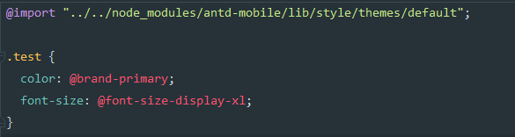

antd-mobile设计变量命名表及设计规范

<https://github.com/ant-design/ant-design-mobile/wiki/%E8%AE%BE%E8%AE%A1%E5%8F%98%E9%87%8F%E8%A1%A8%E5%8F%8A%E5%91%BD%E5%90%8D%E8%A7%84%E8%8C%83>

webstrom链接服务器

<http://blog.csdn.net/wlphyl/article/details/51015734>

<http://www.jb51.net/softjc/125583.html>

cnode数据源

<http://cnodejs.org/api>

表单验证

<https://github.com/fis-components/rc-form>

<https://github.com/jasonslyvia/react-lazyload>

图片延迟加载/占位

react-lazyload

jqH5 cavans 涂鸦插件

<http://www.htmleaf.com/html5/html5-canvas/201505281921.html>

基于react百度地图

<https://github.com/weflex/react-baidu-map>

<https://github.com/xuchaobei/Fang>

基于react的高德地图

<https://github.com/morlay/react-amap>

<https://elemefe.github.io/react-amap/components/about>

Antd设计

<https://design.alipay.com/>

<https://github.com/react-community/create-react-native-app>

<https://segmentfault.com/a/1190000008709892?from=groupmessage&isappinstalled=0>

<https://play.google.com/store/apps/details?id=host.exp.exponent&referrer=www>

Js编码规范

<https://github.com/airbnb/javascript>

正则表达式

<http://www.liaoxuefeng.com/wiki/001434446689867b27157e896e74d51a89c25cc8b43bdb3000/001434499503920bb7b42ff6627420da2ceae4babf6c4f2000>

明达伟亮（实名认证）

React-native 项目

<https://juejin.im/post/58f37cb361ff4b0058f9824a>

<https://github.com/huanxsd/MeiTuan/>

React-native百度地图

<https://github.com/lovebing/react-native-baidu-map>

支付宝支付

<https://github.com/myoula/react-native-payment-alipay>

<https://www.npmjs.com/package/react-native-yunpeng-alipay>

<https://github.com/react-native-component/react-native-smart-alipay>

微信支付

<https://github.com/weflex/react-native-wechat>

React-native-wx

微信登录、分享、支付模块

React-native 中使用antd-mobile

<http://blog.csdn.net/sinat_17775997/article/details/68936093>

React-navigation的简单使用

<http://www.jianshu.com/p/2ce08b92cf60>

<http://www.jianshu.com/p/2f575cc35780>

走马灯在ios中的bug解决方案

autoplay={banners.length > 1}

infinite={banners.length > 1}

dots={banners.length > 1}

修改react-native app 的名称和图标

<http://www.cnblogs.com/busicu/p/5711501.html>

极光推送（android）

<http://reactnative.cn/post/3505>

<https://github.com/jpush/jpush-react-native>

[安卓Back键的处理·基本+高级篇](http://bbs.reactnative.cn/topic/480)

<http://reactnative.cn/post/480>

[Windows环境下IOS APP打包上传AppStore详细流程](http://bbs.reactnative.cn/topic/3600)

<http://reactnative.cn/post/3600>

Antd-mobile Icon在ios中配置

<key>UIAppFonts</key>  
<array>  
 <string>fonts/anticon.ttf</string>  
</array>

Android Studio 和 Eclipse 中获取SHA1详解

<http://bbs.lbsyun.baidu.com/forum.php?mod=viewthread&tid=112007>

<https://github.com/lovebing/react-native-baidu-map/issues/73>

命令keytool -list -v -keystore myapp.keystore

跨平台二维码扫描

<https://github.com/lwansbrough/react-native-camera>

弃用

<https://github.com/cpunion/react-native-barcode-scanner-universal>

<http://www.cnblogs.com/zhangdw/p/6197240.html>

图片选择

<https://github.com/ivpusic/react-native-image-crop-picker>

<http://blog.csdn.net/sinat_17775997/article/details/68932671>

轮播插件

react-native-swiper

Vm ware worksation安装

<http://m.blog.csdn.net/article/details?id=51050770>

<http://jingyan.baidu.com/article/f25ef25444c59a482d1b8270.html>

React native 优秀组件大全

<http://www.marno.cn/>

时间处理插件

<http://momentjs.com/>

Git删除代码插件

rimraf

测试接口工具

<http://www.cnblogs.com/shuaijie/articles/5913750.html>

苹果上架全流程

<http://bbs.reactnative.cn/topic/3600/2017%E6%9C%80%E6%96%B0%E5%8F%91%E5%B8%83%E5%88%B0app-store%E4%B8%8A%E6%9E%B6%E6%B5%81%E7%A8%8B-%E8%AF%A6%E7%BB%86%E5%9B%BE%E6%96%87/2>

react native错误捕捉

<http://m.blog.csdn.net/article/details?id=50942372>

Ios打包上传

<http://bbs.reactnative.cn/topic/3600/2017%E6%9C%80%E6%96%B0%E5%8F%91%E5%B8%83%E5%88%B0app-store%E4%B8%8A%E6%9E%B6%E6%B5%81%E7%A8%8B-%E8%AF%A6%E7%BB%86%E5%9B%BE%E6%96%87/7>

Ios应用名称和包名修改

<http://blog.csdn.net/vivi_12/article/details/53523363>

Ios打包

<http://www.jianshu.com/p/ce71b4a8a246>

扫码

<http://www.jianshu.com/p/2cef1baf9a6f>

Android iOS应用图标生成

<http://www.atool.org/ios_logo.php>

苹果发布应用全流程

<http://www.jianshu.com/p/391f6102b4fb>

在React/Redux应用中使用Sagas管理异步操作

<http://www.jianshu.com/p/0a7fb7134dcf>

Ios启动页设置

<http://blog.csdn.net/hanrovey/article/details/53517865>

React-native ios打包

<http://www.jianshu.com/p/ada5243d5acc>

计算英语单词的数量

<https://zhidao.baidu.com/question/1539687254842216707.html>

Facebook应用申请参考文档

<http://www.jianshu.com/p/dd35278ee0a3>

申请keyhash

<http://blog.csdn.net/u010838555/article/details/39851863>

Unicode字符编码分布表——标点符号类

<https://wenku.baidu.com/view/379ca5697e21af45b307a8d8.html>

<http://blog.csdn.net/xiaokui_wingfly/article/details/51999990#%E6%A0%87%E7%82%B9%E5%92%8C%E7%AC%A6%E5%8F%B7>

unicode 编码在线转换工具--javascript

<http://www.cnblogs.com/mq0036/p/4007452.html>

Git使用教程

<http://www.runoob.com/w3cnote/git-guide.html>

Js图片预览  
<https://github.com/LS1231/vue-preview>

<http://photoswipe.com/>

插件打包

<https://cnodejs.org/topic/5833e104bde2b59e06141e16>

### Web前端攻城狮（基础篇）

<http://www.xuetangx.com/courses/course-v1:TsinghuaX+44100343X+2017_T1/about>

# [vue-preview](https://github.com/LS1231/vue-preview)

<https://github.com/LS1231/vue-preview>

Js图片预览

<http://photoswipe.com/>

Npm包安装量

<https://npm-stat.com/charts.html>

Vue2.0环境搭建

<http://www.jianshu.com/p/5ba253651c3b>

用Google Cloud Platform搭建Shadowsocks服务教程

<http://godjose.com/2017/06/14/new-article/>

React-native 项目

<https://juejin.im/post/58f37cb361ff4b0058f9824a>

<https://github.com/huanxsd/MeiTuan/>

React-native百度地图

<https://github.com/lovebing/react-native-baidu-map>

<https://github.com/zzzkk2009/react-native-baidu-map>

支付宝支付

<https://github.com/myoula/react-native-payment-alipay>

微信支付

<https://github.com/weflex/react-native-wechat>

<https://github.com/xiaozhicheng/react-native-pay>

<https://github.com/weflex/react-native-wechat/issues/128>

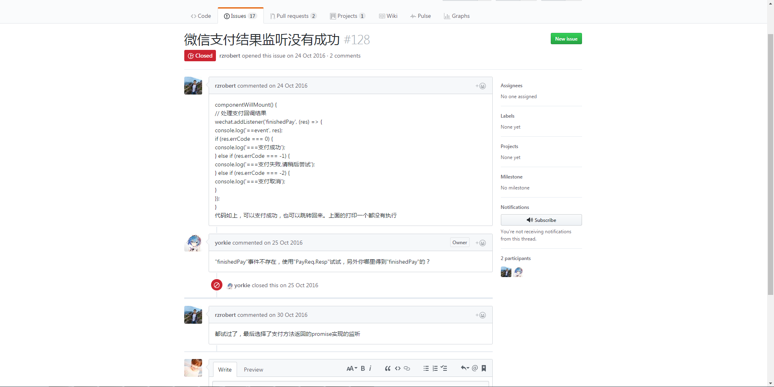

try {

if(!isWeChatInited){

let registerInfo = await WeChat.registerApp(ShareConf.WeiXinAppId)

console.log("registerInfo:", registerInfo)

let isWeixinInstalled = await WeChat.isWXAppInstalled()

console.log("isWeixinInstalled:", isWeixinInstalled)

if(!isWeixinInstalled){

throw "weixin not installed"

}

isWeChatInited = true

}

let weiPayInfo = await weixin_generate_order(payOrder.billAliseId)

console.log("weiPayInfo:", weiPayInfo)

let result = await WeChat.pay(

{

partnerId: weiPayInfo.partnerid, // 商家向财付通申请的商家id

prepayId: weiPayInfo.prepayid, // 预支付订单

nonceStr: weiPayInfo.noncestr, // 随机串，防重发

timeStamp: weiPayInfo.timestamp, // 时间戳，防重发

package: weiPayInfo.package, // 商家根据财付通文档填写的数据和签名

sign: weiPayInfo.sign // 商家根据微信开放平台文档对数据做的签名

}

);

console.log('Pay result:', result);

return Promise.resolve(AppEnum.NetResSuccess)

} catch (error) {

console.log('Pay fail error:', error);

return Promise.reject(AppEnum.NetResFail)

}

React-native-wx

微信登录、分享、支付模块

React-native 中使用antd-mobile

<http://blog.csdn.net/sinat_17775997/article/details/68936093>

React-native实战经验分享

<https://jaggerwang.net/react-native-cross-platform-mobile-app-develop-intro/>

调用系统地图

<http://bbs.reactnative.cn/topic/1705/%E6%96%B0%E8%BD%AE%E5%AD%90-%E8%B0%83%E8%B5%B7%E5%9C%B0%E5%9B%BEapp%E5%AE%9E%E7%8E%B0%E8%B7%AF%E5%BE%84%E8%A7%84%E5%88%92%E5%AF%BC%E8%88%AA%E7%AD%89>

React-native 高德地图

<https://github.com/react-native-component/react-native-smart-amap>

批量加载module

<https://github.com/dvajs/dva/issues/589>

require.context('./models/', true, /\.js$/).keys().forEach( file => app.model(require(`./models/${file.slice(2)}`)) )

修改android包名

<https://segmentfault.com/q/1010000005609103>

<https://www.ibm.com/developerworks/cn/mobile/mo-bluemix-react-native-ios8/>

修改苹果应用名称

<http://www.cnblogs.com/allenxieyusheng/p/5802179.html>

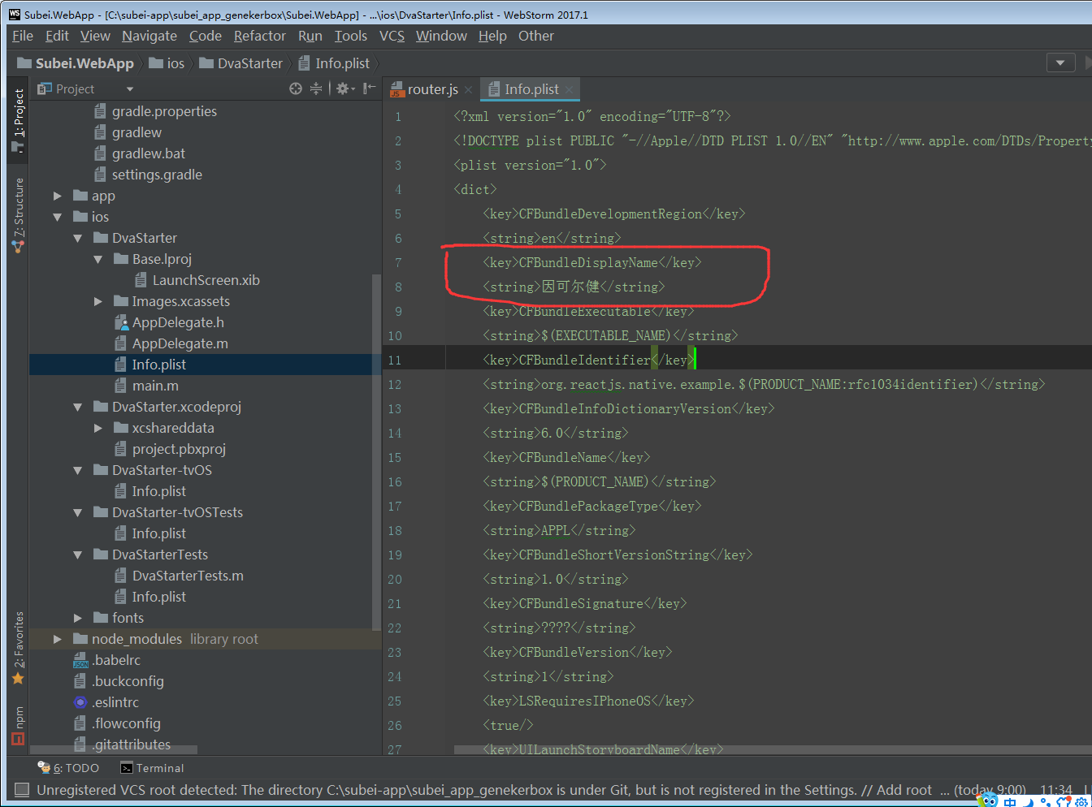

React native 热跟新

<https://github.com/reactnativecn/react-native-pushy/blob/master/docs/guide.md>

<https://github.com/reactnativecn/react-native-pushy/blob/master/docs/guide2.md>

操作流程

<http://blog.csdn.net/ruancanghui/article/details/51280077>

React native介入微信api

<http://blog.csdn.net/u011413061/article/details/53196401>

React native接入支付宝api

<http://blog.csdn.net/u011413061/article/details/53183370>

图片上传

<http://www.jianshu.com/p/c5b8c0f2459a>

Ndk下载地址

<http://www.yinqisen.cn/blog-740.html>

安装引导

<http://www.2cto.com/kf/201601/486603.html>

[Windows环境下IOS APP打包上传AppStore详细流程](http://blog.csdn.net/sinat_17775997/article/details/71305822)

<http://blog.csdn.net/sinat_17775997/article/details/71305822>

移动端兼容性问题总结

<http://blog.csdn.net/hardgirls/article/details/51722519>

Webpack中文文档

<http://www.css88.com/doc/webpack2/concepts/entry-points/>

webpack 插件 svg-sprite-loader配置

<https://cisy.me/webpack-svg-sprite/>

使用git上传项目到github

<http://blog.csdn.net/hanhailong726188/article/details/46738929>

webstorm中js文件被识别成txt类型

<http://www.voidcn.com/article/p-xbascmti-rp.html>

新建项目并放到github上

<https://www.cnblogs.com/sunala/p/6563985.html>

（git pull 失败 ,提示：fatal: refusing to merge unrelated histories

解决方案：git pull origin master --allow-unrelated-histories

）

从零构建Webpack开发多页面应用

<https://github.com/riskers/blog/issues/27>

git安装配置流程

<https://www.cnblogs.com/superGG1990/p/6844952.html>

<http://blog.csdn.net/hyr352114576/article/details/50553454>

git-tfs使用

<https://www.cnblogs.com/superGG1990/p/6844952.html>

<https://gittf.codeplex.com/>

在webstorm上使用tfs

<http://www.jianshu.com/p/46e7c7331c77>

react-router v4 中文文档

<http://reacttraining.cn/>

<http://blog.csdn.net/sinat_17775997/article/details/69218382>

<http://www.jianshu.com/p/27ee7df4ccc1>

npm install 报错 sha1

<http://www.80000s.com/archives/536>

eslint中文

<https://cn.eslint.org/docs/rules/>

javascript编码规范

<https://github.com/airbnb/javascript>

<https://github.com/standard/standard>

<https://github.com/sivan/javascript-style-guide/blob/master/es5/README.md（airbnb>编码规范中文版）

rn编码规范

<https://github.com/sunyardTime/React-Native-CodeStyle>

svn使用文档

<http://blog.csdn.net/dily3825002/article/details/6717076>

javascript ASI(自动插入分号)机制

<http://cnodejs.org/topic/56dbbd25820d3c9b3d63e369>

查看浏览器对ES6的支持情况

<http://kangax.github.io/compat-table/es6/>

接口测试工具

<http://www.hitchhiker-api.com/>

接口测试工具使用说明文档

<https://github.com/brookshi/Hitchhiker/blob/master/README_cn.md>

jest测试工具中文官网

<http://facebook.github.io/jest/zh-Hans/>